Gaussian Vector Simulation

ECE3093 Assignment 2 Part B, Written by Kun Zhang (22701478)

Note that the sequential organised MATLAB codes are appended at the end.

# Question 1

## Question 1 (i) Covariance matrix

The assigned values are



The covariance matrix is thus

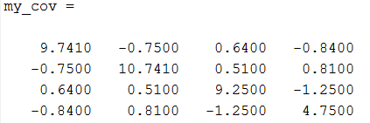

**(a) Check symmetry of my_cov**

By definition, a symmetric matrix is a square matrix that is equal to its transpose. Therefore, symmetry of my_cov can be checked by:

sym_check=my_cov-my_cov';

sym_check was zero after running the code, which indicated that my_cov was symmetric.

**(b) Check my_cov is positive definite**

A positive definite matrix has only positive eigenvalues. By conducting eigenanalysis, it was found that the eigenvalues were:

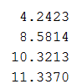

all of which were positive, thus my_cov was positive definite.

## Question 1 (ii) Expectation vector

The expectation vector my_exp was constructed as

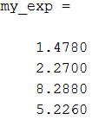

# Question 2

## Question 2 (i) Compute M and prediction error

Given the covariance matrix, we can know its sub-matrices by:

cov_Y=my_cov(2:end,2:end); %Cov(Y)

cov_XY=my_cov(1,2:end); %Cov(X,Y)

cov_X=my_cov(1,1); %Cov(X)

M matrix was computed by $Cov\left(X,Y\right){Cov(Y)}^{-1}$, which was

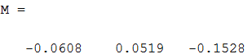

The variance of the innovation (prediction error)

$$var(X-P\left(X | Y\right)=Cov\left(X\right)-M×{Cov(X,Y)}^{-1}$$

and we have

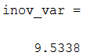

## Question 2 (ii) State the distribution of the innovation

The variance of the innovation was calculated to be 9.5338. Since we know the random variables the predictor is unbiased, we can draw the conclusion that the expectation is zero.

Therefore, the distribution of the innovation was

$$X-P\left(X | Y\right) \sim N(0,9.5338)$$

## Question 2 (iii) State the distribution of the best linear prediction of X

With the assigned U, V and A, the observed value y became:

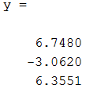

The best linear prediction $P\left(X | Y=y\right)=E\left(X\right)+Cov\left(X,Y\right){Cov(Y)}^{-1}(Y-E\left(Y\right])$ was

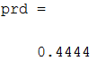

The distribution from best linear prediction is given by

$$X \sim N_{1}(P\left(X | Y=y\right),var(X-P\left(X | Y\right))$$

which in the case, the distribution was

$$X \sim N_{1}(0.444, 9.5338)$$

# Question 3

## Question 3 (i) Explain how X maps to Y

Affine transport states the following mapping

$$X \sim N_{2}\left(a,C\right) => Y= ψ(X) \sim N_{2}\left(ψ(b),MCM^{T}\right)$$

where $M=Cov\left(X,Y\right){Cov(Y)}^{-1}$

C was proved to be symmetric and positive, thus C can be decomposed as

$$C=QDQ^{T}$$

Define $Y=Q^{T}(X-a)$, then

$$Y\sim N_{2}\left(Q^{T}(E\left(X\right)-a),Q^{T}CQ\right)$$

With $E\left(X\right)-a=0$ and $C=QDQ^{T}$, we have

$$Y\sim N_{2}\left(Q^{T}(E\left(X\right)-a),Q^{T}QDQ^{T}Q\right)$$

$$Y\sim N_{2}\left(0,D\right)$$

## Question 3 (ii)(iii) Scatter plot of X

The covariance matrix is divided in such way:

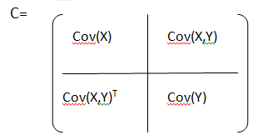

X with 3000 points was computed using two methods:

The first one used spectral decomposition with

$$X=E\left(X\right)+Q\sqrt{D}Z$$

where Z was a standard normal vector

The second one used the MATLAB built-in function MVNRND, which calcuated random vectors from the multivariate normal distribution. The plots are shown below

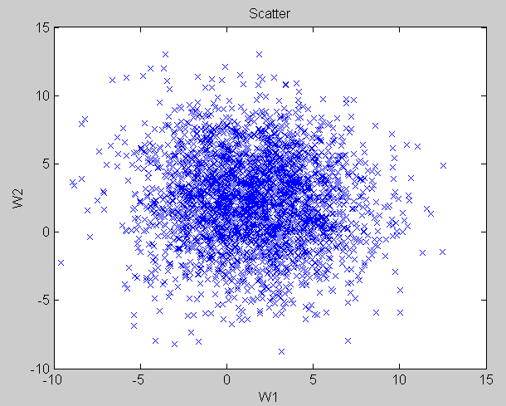

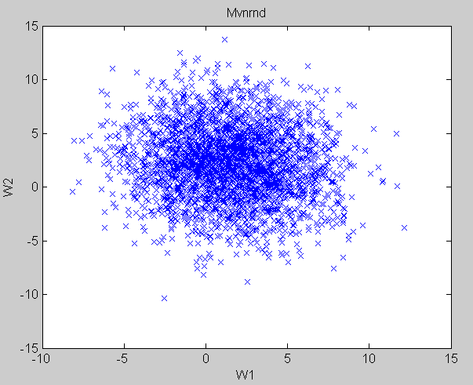

The plots of (ii) and (iii) are observed to have similar patterns but vary in exact values. This difference can be attributed to the random function, which would generate different values randomly each time the function is executed. As a result, the distribution would not be exactly the same

## Question 3 (iv) Contour Plot

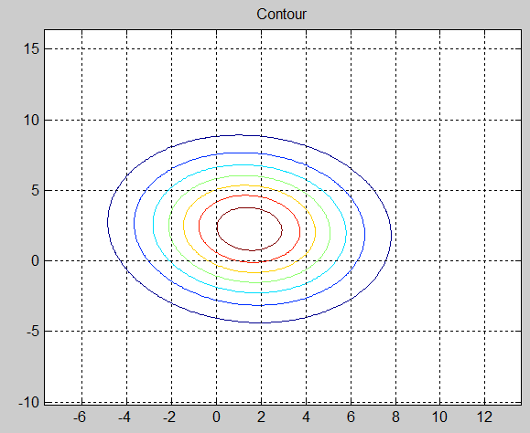

The contour map shows the distribution of WA and WB.

The eigenvalues determine the shape of the ellipses by determining the length of the axis and the eigenvectors determine the basis of the ellipse

## Question 3 (v) Compute M

Similar to Question 2(i), M was calculated to be

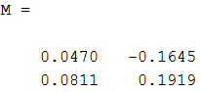

## Question 3 (vi) Compute best linear prediction of X

With the assigned U and V, y became:

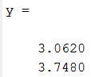

Similar to Question 2(ii), the best linear prediction vector was evaluated to be

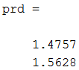

From the contour plot, it can be observed the expectance, which is the origin of the contours, is very close to the prediction vector. This verifies that the prediction is reasonable.

## Question 3 (vii) State the distribution of the innovation

Similar to Question 2 (ii),

The variance of the innovation was calculated to be:

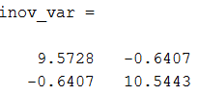

The expectance was zero because the prediction was unbiased.

Hence, the distribution of the innovation was

$$X-P\left(X | Y\right) \sim N(0,,inov_var)$$

## Question 3 (vii)(ix) Simulate $P\left(X | Y\right)$ and Y

With

$$P\left(X | Y\right)=E\left(X\right)+Cov\left(X,Y\right){Cov\left(Y\right)}^{-1}(Y-E(Y))$$

and

$$Y=E\left(Y\right)+Q\sqrt{D}Z$$

$P\left(X | Y\right)$ and **Y** were obtained and ploted by having 3000 points

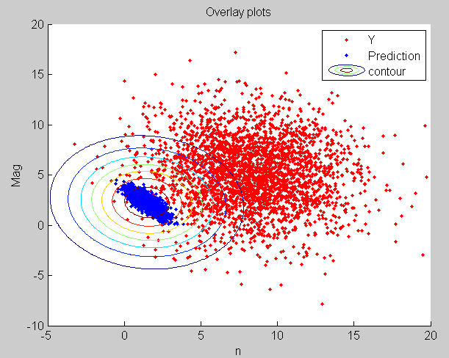

The scatter plot of prediction and the coutour maps show similar pattern as expected. The foromer, however, would be more accurate as the prediction was based on known values Y. This means that it would be closer to the origin of the contours. The covriance and epxpectation of Y are greater than those of the others, which makes the scattered plot of Y isolated from the others. This corresponds to the large covariance between X and Y.

# Appendix

%Written by Kun Zhang

%ID 22701478

%--------------------------------------------------

%reconstruct convariance matrix (3,4,1,2)

clc;clear all;close all;

%assigned variable

A=3;

U=1.478;

V=2.27;

Z=8.741;

%% Question (1)(i)

my_cov=[Z+1 -0.75 0.64 -0.84

-0.75 Z+2 0.51 0.81

0.64 0.51 9.25 -1.25

-0.84 0.81 -1.25 4.75]; %covariance matrix

sym_check=my_cov-my_cov'; %if zero matrix, symmetric

eig(my_cov); %if all eigenvalues>0, positive definite

% Question (1)(ii)

my_exp=[U;V;U+3*V;2*U+V]; %expectation vector

%% Question (2)(i)(ii)

cov_Y=my_cov(2:end,2:end); %Cov(Y)

cov_XY=my_cov(1,2:end); %Cov(X,Y)

cov_X=my_cov(1,1); %Cov(X)

exp_X=my_exp(1);

exp_Y=my_exp(2:end);

M=cov_XY/cov_Y; %Cov(X,Y)/Cov(Y)

inov_var=cov_X-M*cov_XY'; %var(X-P(X|Y) Prediction error

%% Question (2)(iii)

y=[U+V+A U-2*V U*V+A]'; %y - known Y

% prd=exp_X+M*(y-exp_Y); %P(X|Y=y)

%% Question (3)(i)

N=3000; %simulation point

cov_X=my_cov(1:2,1:2); %Cov(X)

cov_Y=my_cov(3:end,3:end); %Cov(Y)

exp_X=my_exp(1:2);

exp_Y=my_exp(3:end);

cov_XY=my_cov(1:2,3:end)

%% Question (3)(ii)(iii)

[Q D]=eig(cov_X); %spectral decomposition

Z=randn(2,N); %standard normal Z

X=diag(my_exp(1:2))*ones(2,N)+Q*sqrt(D)*Z; %X=[W1 W2]

W1=X(1,1:end);

W2=X(2,1:end);

wmv=mvnrnd(exp_X,cov_X,3000); %MVNRND Random vectors from the multivariate normal distribution.

%plots

figure(1)

plot(W1,W2,'x')

title('Scatter');

xlabel('W1');

ylabel('W2');

figure(2)

plot(wmv(:,1),wmv(:,2),'x')

title('Mvnrnd');

xlabel('W1');

ylabel('W2');

%% Question (3)(iv)

xmin=min(W1);

xmax=max(W1);

ymin=min(W2);

ymax=max(W2);

xstep=0.1;

ystep=xstep;

[x,yy]=meshgrid(xmin:xstep:xmax,ymin:ystep:ymax); %construct meshgrid

[nx,ny]=size(x);

z=mvnpdf([x(:) yy(:)],exp_X',cov_X); %multivariate pdf

z=reshape(z,nx,ny);

figure(3)

contour(x,yy,z) %contourplots

title('Contour');

grid on

%% Question (3)(v)

M=cov_XY/cov_Y; %Cov(X,Y)*Cov(Y)^-1

%% Question (3)(vi)

y=[2*V-U U+V]'; %y - known Y

prd=exp_X+M*(y-exp_Y); %a=P(X|Y=y)

%% Question (3)(vii)

inov_var=cov_X-M*cov_XY'; %K=var(X-P(X|Y) Prediction error

inov_exp=sqrt(inov_var); %a=E(X-P(X|Y)

%% Question (3)(viii)

[QY DY]=eig(cov_Y); %spectral decomposition

ZY=randn(2,N);

PX_Y=diag(exp_X)*ones(2,N)+M*Q*sqrt(D)*Z;

Y=diag(exp_Y)*ones(2,N)+Q*sqrt(D)*Z;

%% Question (3)(ix)

figure(4)

hold on

plot(Y(1,:),Y(2,:),'r.')

plot(PX_Y(1,:),PX_Y(2,:),'.')

contour(x,yy,z)

title('Overlay plots');

xlabel('n');

ylabel('Mag');

legend('Y','Prediction','contour');